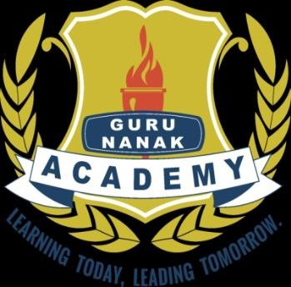

**GURUNANAKACADEMYPARTAPPURA**

**(TobeaffiliatedofCBSE,EnglishMedium,Co-educationalInstitute)**

**PARTAPPURA**

**PROSPECTUS**

Motto

Learningtoday,Leadingtomorrow

Visio

Tobethebestnewgenerationinstitutionprovidingallroundgrowth and development to capture the path of success.

Mission

1. Enpowerthechildrentofacetheglobalchallengesconfidently by grooming their innate capabilities.

Or

Toprovideclasseducationtodevelopinnatecapabilitiesof thestudentsso that they can meet confidently the global challenges as enpoweredcitizens of their country .

1. westressthetotaldevelopmentofeachchild: spiritual,moral,intellectual , social, emotional and physical.

**CHAIRMAN’SMESSAGE**

**DIRECTOR’SMESSAGE**

**PRINCIPAL’SMESSAGE**

*‘Learningisnottheproductofteaching,Learningistheproductoftheactivityoflearners‘-JohnHolt*

*IamhonouredandfeelveryprivilegedtobetheprincipalofGuruNanakAcademyPartappura.ASchoolisaplaceentanglinglearningandjoycombiningknowledgeandlessonoflifeforanensichedlamonousEducationmustaimanaspects,Whichcontributetothedevelopmentoftheyoungmindsastheystepintothecontemprary worldOurendeavorhasbeentoeslabtishatmospherethatfostercreativityandinculcatethespiritoflearninginyoungexploringstudents.Weareherenotonlymonitoringthe studentbuttheinculcateintheimpressiblemindstopricelessethicsofdignity, honesty,compassionandpatriolism.Webelieveincollaborativelearning,strong relationshipandbuiblingcapacityamongourchildrentotheirownniche.Impartingeducation I not a technique or a way,*

*WeareconfidentthatarmedwithinnerstrengthourGuruNanakAcademianswillstayfirmlyrootedinethosandwillcontinuetogivethemselvestoftiergoals*

*Wearecommittedfortheenlightmentandallrounddevelopmenttoourstudents.*

*Mrs.Mandeepkaur*

**GNAKINDERGARTEN(PRE-PRIMARY)**

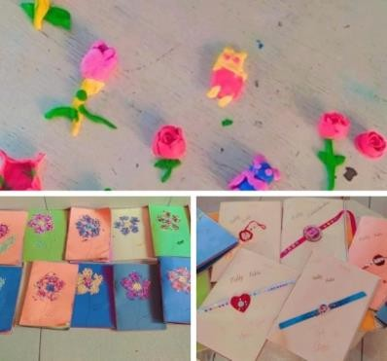A home away from home with a hygienic environment for the young ones, GNA kindergarten is a wonderful world

of fun and learning.We plan and create activities that help growing children in developing learning abilities. We provide an enlighteningandsafeenvironmentwhere

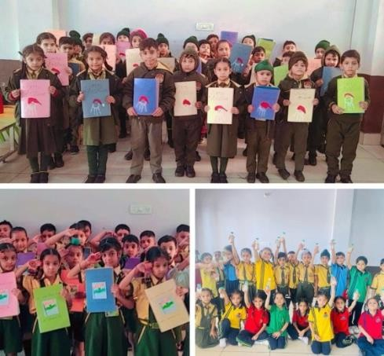children enjoy playing

and learning .Playcentric activities foster the major domain of development such as social, emotional, language, cognitive, sensory,fineandgrossmotorskills.

**Primary&MiddleSchool**

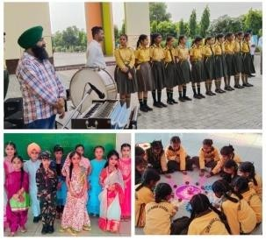The contours of knowledge know no bounds Guru Nanak AcademyPartappura recognize this features andgives each students rigrous exposure to group activities, seminars, visual learning and poject works.The aim is to promote and intensify performance and encourage students to be fore- runners in all fields.

**INFRASTRUCTURE&AMENITIES**

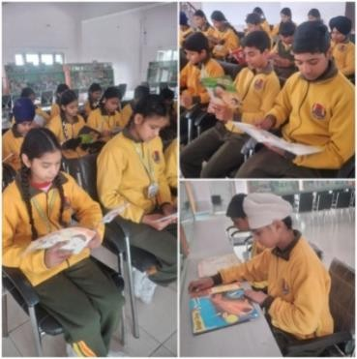**LIBRARY–**The schoollibrary is thehub of intellectualactivitiesand is richinreadingmaterialandrefrenceresources,whichprovide information and ideas that are fundamental to functioning successfully in todays information and knowledgebased

society.

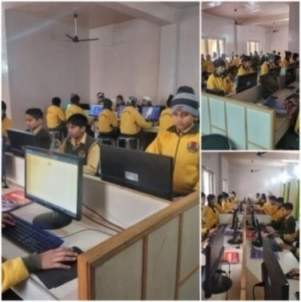**COMPUTER LAB –**Students at Guru Nanak Academy are instructed on thebasics of computer use as early class I ina well equipped lab.

**MATHS ANDS.S.TLAB –**These labs provideopportunity for children to enjoy mathematics and social science, understand it and solve meaningful problems.

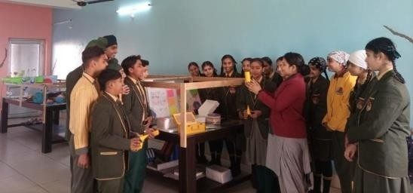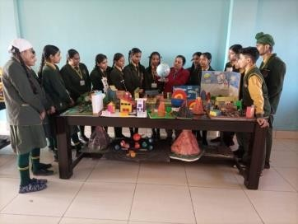

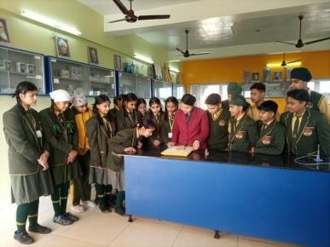**SCIENCE LAB –**Guru Nanak Academy has an extensive science lab which provides an experimental foundation for the concepts introduced.

**DIGITALBOARDS–**Childrenneedtheskillsets,whicharebeyond

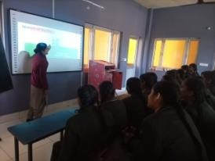subject knowledge and require concentration, assimilation and retention. In this regard the role ofsmart class is quiteimportant.Watching highly enjoying visuals and animations makes learning enjoyable.

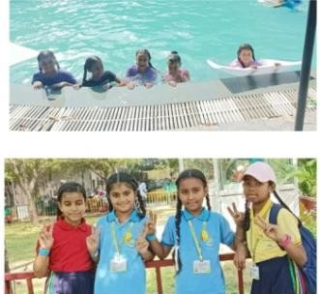**CO-CURRICULARACTIVITIES**

Fieldstripsforrealworldexperienceandtoenhancethe information taught in the curriculum.

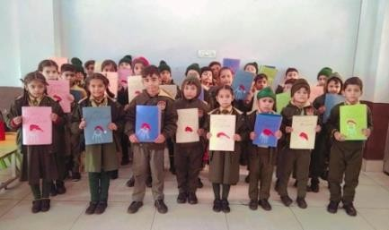Art and craft to teach a variety of skills like creativity, confidence, visual learning decision making etc.

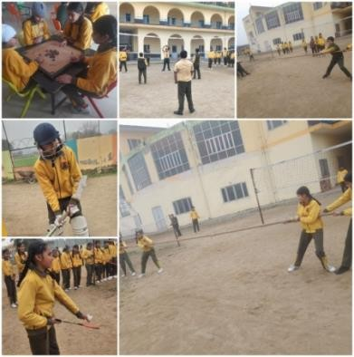Sportsisinclusionofgamesin ourcurriculums of studiesis very important for physical and mental wellbeing of ourstudents

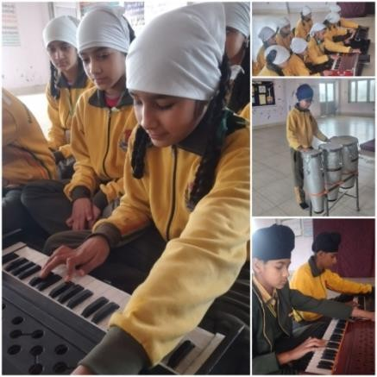Musicclassesinourschoolservesasaplatformfor creating tiny musicians of all genres and skill level. It enables them to vocals and instruments.

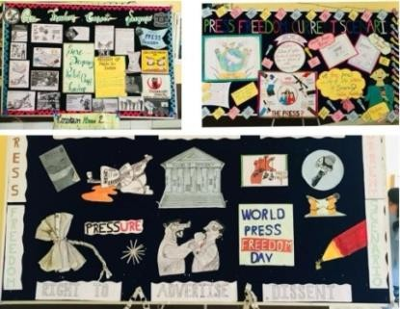Celebration of special days have become an integral part of joyful learning, community building and thought provoking processes.

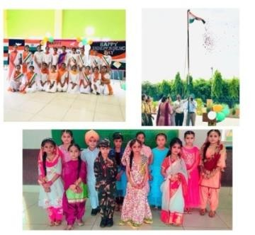Monthly competitions-Every month class competition and inter house competitions are conducted, a platform to demonstrate talent to achieving greater things in life.

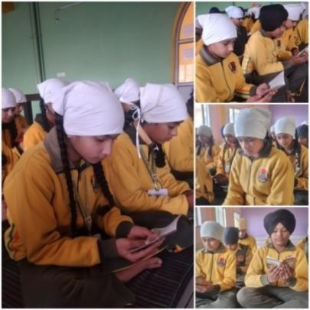Value education classes are an integral part of our school where moral values are enhanced through principles of Gurbani.

Club activities to create awareness like know our rich ancient culture and tradition,realizethe importanceofhealthy environment orlearn about nutrition, healthy, eating etc.

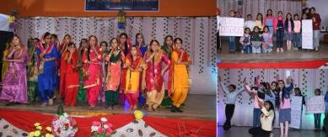

**VISIONOFTRUST/SOCIETY**

Guru Nanak Academy runs under the ageis of Punjab development trust, which was formed in the year 2003 to provide quality and holistic education to its students from year 2017.We want our students to go through a curriculums that is stimulating, creative, child-centred so that a learner can explore multiple dementions of excellence and engaging them beyond the classroom through a wide spectrum of opportunities.

# Whatmakesustrulydistinctive?

* Celebrateacultureofexcellenceinacademicsandtheallround development of children.
* Individualattentiontoeachchildtocatertotheirdiverselearning needs.
* Talented,experiencedanddedicatedteacherswithculturaldiversity.
* Outstandingacademicsanditcurricularresults.
* UploadsIndiancultureandvalues.
* A safe and secure learning environment with focus on studentwellbeing.

# CURRICULUM

The designing of a school curriculum requires a vision. Detailed evaluation and improvementare made year after year in the curriculum this had made it imperativeforustodevisethemosteffectivemethodfortheimplementationof the requirements of the curriculum .As we are following the CBSE pattern we devote intensive teaching methods along withco-curricular activities andfollow CBSE exam patterns

**PRE-PRIMARY**

The pre -primary wing of the school consists of Play Group , LKG and UKG and caters to the needs and demands of early childhood. Bearing in mind that the foundation of a child’s personality is laid and two third of his intellect formed at this age , We have created an environment and a system of teaching which is entirelychildfriendly.FormallearningofthethreeRsisintroducedinplaygroup&LKG. It finds a more prominent place in the UKG curriculum, Which includes recognition, reading and writingof English, Punjabiand Hindi alphabets and small words and also basic arithmeticalconcepts.

**PRIMARYCURRICULUM**

The Syllabus become more board based at this level and gradually the young learner is exposed to a wide range of subjects and study materials which is suitably graded. Apart from Mathematics, English, Punjabi, and Hindi, subjectlikeGeneralScienceandE.V.S/SocialScienceareintroducedcomputerscienceis introduced in class I. As early as class I students learned to work on computers,in the multimedia lab which has been specially equipped to meet the need of young learners. Divinity is also part of curriculum from grade-I to enhance the moral values in young leaners.

**UPPERPRIMARYCURRICULUM**

StudentsofUpperPrimarystudyEnglish,Hindi,Punjabi,Mathematics,Computer Science, Science and Social Science Co-curricular activities include physical and Health Education, Work experience and Art education.

**AdmissionGuidelines**

1. EveryParentsshouldfilltheregistrationformfirstfor admission in school.
2. AdmissiontogradesNurserytoUKGwillbethroughinformal interaction of the parents and child with the Head of the school and teacher.
3. Admission to grade I and above will be based on the written entranceexamconductedforthechild.Dateandtimeforthe entrance test will be intimated to the parents.
4. Finaldecisionofgivingofadmission(andinwhichclass)willbe of the management based on the test.
5. Alltheadmissionwillstrictlydependupontheagecriteria.No exception will be made under any circumstances .The management decision will be final.
6. Fee may be paid in the school account office on all working daysorotherwisethroughonlinepayment.Firstmonthfeehas to be paid along with the admission fee and that is nonrefundable.
7. Feecanbe paidyearly,halfyearly,quarterlyormonthlybasis.
8. Latefeepenalty-Ifthefeeisnotpaidbythestipulateddate,a late fee penalty of RS 10/day (including holidays) will becharged.
9. Non-payment of fees for further of 30 days after the pay by dateshallresultincancellationofadmission.Toreinstatethe admission a penalty will be charged in addition the late fee payment penalty.

**DocumentRequiredattheTimeofAdmission**

* + Self attested copy of the birth certificate, proof of residenceaddress–Aadharcard/passport/electricity bill/Voter Id.
  + Photocopyofchild’sAadharcard.
  + Schoolleavingcertificate(classLKGonwards)
  + E-Punjabcertificate(classLKGonwards)
  + Latestreportcardof thelast schoolattended
  + (classLKGonwards)
  + Photocopyofparents/guardiansAadharcard.
  + Passportsizephotoofchildandparents/guardians.

|  |  |  |
| --- | --- | --- |
| Class | Minimumageason31stMarchoftheyear in which the admission in sought | Maximumageason31stMarchofthe yearinwhichtheadmissioninsought |
| Nur. | 2years | 4years |
| KG | 3years | 5years |
| prep | 4year | 6years |
| I | 5years | 7years |
| II | 6years | 8years |
| III | 7years | 9years |
| IV | 8years | 10years |
| V | 9years | 11years |
| VI | 10years | 12years |
| VII | 11years | 13years |
| VIII | 12years | 14years |